Ten or More Releases in 2024

Brad Evans 479
Patrick Klingensmith 367
Carl Conrad 258
Chuck McKnight 171
Maurice Potvin 165
Bob Marshall 160
David White 108
Tim Graham 92
William Lambert 92
Matt Davies 72
George Weber 72
Dana Lavy 57
Kevin LaRoche 51
David Stephenson 41
Donald Gutshall 40
Tony Crisp 38
Jeff Kamin 32
Adam Starr 31
Robert Basic 29
Charles Klingensmith 28
Phillip Jarvis 26
Josh Marshall 25
Ray Elkins 22
Cooper Marshall 20
John Ringenbach 20
Nate Walden 19
Greg Hastings 18
Derek Halas 15
Tyler Lynn 15
John Proch 14
Patrick Andino 13
Richard Hunt 13
David Noel 13
Tammy Graham 12
Jim Cook 11
Shawn Lansinger 11
Addison Davies 10
Mike Erwin 10
Keith Stayer 10
Richard Thorp 10

Event Winners

IceBreaker
Leesville March 23
1st Place – Colton Harmon
2nd Place – David White
3rd Place – Gary Andreis
May Madness
Piedmont May 18
1st Place = Troy Oliver
2nd Place – Cooper Marshall
3rd Place – Rich Daniels
Battle of Ohio
Ohio Lakes June 7-9
1st Place – Kyle Jones
2nd Place – Mikel Smiddy
3rd Place – Jesse Wolford

12th Annual Minnow Fund Outing
West Branch/Milton Sept. 14-15
1st Place – Justin Harbin
2nd Place – Alex Turner
3rd Place – Austin Blauser
54th Annual Main Event
Salt Fork Lake Oct. 12-13
1st Place – Brad Evans
2nd Place – Cash Naftzger
3rd Place- Gary Andreis
LungeFest
Leesville Nov. 2
1st Place – Hunter Miller
2nd Place – Brad Evans
3rd Place – Jason Westbrook

2024 Overall Tournament Winner
Brad Evans
15 Muskies
211.5 Points

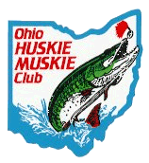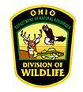
64th
ANNUAL
OHIO HUSKIE
MUSKIE CLUB INC.
MEETING AND AWARDS
BANQUET
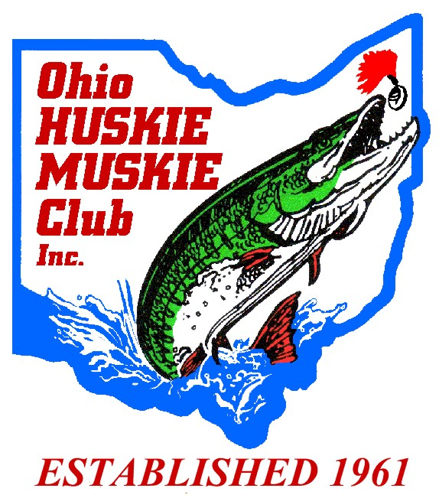
February 15, 2025
SYB Party Center
4157 Hudson Drive
Stow, Ohio 44224
OHMC Officers
President – Chad Harmon
1st Vice President – David Simmons
2nd Vice President – Rich Daniels
Secretary – Ken Proffitt
Treasurer – John Ringenbach

Trustees
Jeff Ferjutz Past President
Gary Andreis
Derek Halas
Phillip Jarvis
John Proch
Phil Ringenbach
Tim Smith
Tyler Lynn
Rick Simpson
Rick Thorp
David White

Social Media
John Proch

Program

4:00 pm – Business Meeting
5:00 pm - Social Hour
6:00 pm – Banquet Starts
7:00 pm – Recognition of Guests
7:15 pm - ODNR Presentation
MWCD Presentation
7:30 pm - Awards

Joe Blackwell “Mr. Muskie” Award
2015 – Fred Lederer
2016 – Tim Smith
2017 – Scott Hale
2018 – Chad Harmon
2019 – Keith Ott
- – Jerry Rice
- - Kevin Page
Curt Wagner
- – Elmer Heyob
- - John Ringenbach
- - Bob Basic

Woman of the Year Award
2015 – Stephanie Neville
2016 – Gloria Roberts
2017 – no winner
2018 – Kortney Harmon
2019 – Danielle Ott
- – Maggie Butara
2021– no winner
2022 – no winner
2023 – Donna Ball
2024 – Anna Land

Dr. L.G. Dunmire Muskie Award

Brad Evans 119
Patrick Klingensmith 71
Carl Conrad 55
David White 25
Bob Marshall 22
Tim Graham 19
Matt Davies 17
George Weber 14
Kevin LaRoche 13
Donald Gutshall 12
Dana Lavy 11
Adam Starr 10
Robert Basic 10
Maurice Potvin 8
Charles Klingensmith 7
Nate Walden 6
Tony Crisp 5
Jeff Kamin 5
Josh Marshall 5
Ray Elkins 5
John Ringenbach 5
Alex Leglise 5
William Lambert 4
Shawn Lansinger 4
Addison Davies 4
Richard Thorp 4
Gary Andries 4
Derek Halas 3
Tyler Lynn 3
Keith Stayer 3
Chad Harmon 3
Eric Smeltzer 3

Fifty-Inch Award
First Time 50” Catch

Dana Lavy 50”
Leesville Lake
February 2, 2024

Gary Andreis 50.5”
Pymatuning Lake
March 20, 2024

Matthew Smith Memorial
Award for Juniors 2024

Boys
Colton Harmon 47”
Leesville Lake
March 23, 2024

Girls
Addison Davies 49.75”
West Branch
June 17, 2024

Queen Royalty 2024

Addison Davies 49.75”
West Branch
June 17, 2024

2024 H.E. “Pooch” Curry Award

Brad Evans 52.25”
Piedmont Lake
January 6, 2024

